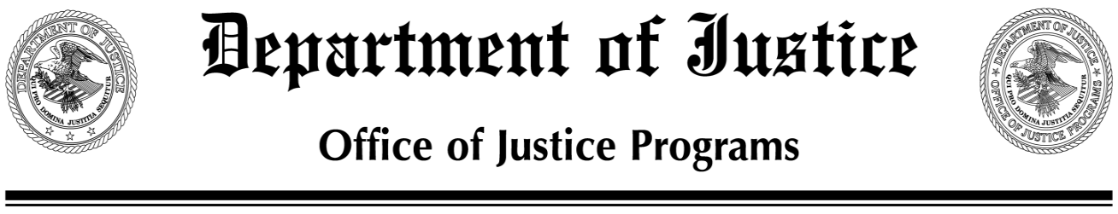
EMBARGOED FOR RELEASE Office of Justice Programs
8:30 a.m. EDT Contact:
MONDAY, April 4, 2011 Starr Small, 202-598-9457
www.ojp.gov Michelle Muth Person, 202-569-3167

FEDERAL AGENCIES HOST SUMMIT ON PREVENTING YOUTH VIOLENCE
Six Cities Present Plans to Address Community Needs

WASHINGTON—Today mayors and other officials from six cities presented comprehensive plans to prevent youth violence in their communities. The plans were outlined at the Summit on Preventing Youth Violence in Washington, D.C., hosted by the Department of Justice and other federal agencies. In addition to members of Congress, the audience included representatives from the public and private sectors.

“I’m pleased that these six cities responded so quickly after President Obama launched the National Forum on Youth Violence Prevention last October,” said Laurie O. Robinson, Assistant Attorney General for the Office of Justice Programs. “These plans reflect a serious commitment to multi-disciplinary, data-driven approaches to preventing and reducing youth violence. I believe these plans offer ideas that will help these and other communities make our children safer.”

The Departments of Justice, Education, Health and Human Services, Housing and Urban Development, Labor and the White House Office of National Drug Control Policy are collaborating to provide technical assistance to the Forum’s participating cities. These cities, Boston; Chicago; Detroit; Memphis, Tenn.; Salinas, Calif.; and San Jose, Calif., were selected based on need, geographic diversity, and willingness and capacity to develop comprehensive plans.

More details about the Forum and summaries of the city plans are available at: www.findyouthinfo.gov.

###

